William Brand
- Mercury Malefactor
- Admin

- 8,884 posts
- Gender:Male
- Location:Logan, Utah
- Interests:My name is William Pace and I live and work as a graphic designer, illustrator and photographer in Northern Utah. I'm married to the lovely Tracy Pace and we have three children. In addition to all things art, I enjoy traveling and meeting new people from every walk of life. I've always been a fan of history, theology, and of course, Pyracy.
http://www.youtube.com/watch?v=PSkt-q-HihQ
Posted November 8, 2009 · Report post
With Gibbet Jones offering to make period buckles from examples in art and exhibits, I'm putting out a request for buckles in art. Please post images of fancy, unique and even common buckles for shoes, belts, bags and baldrics of the period. The greater the detail in art and etchings the better. Any individual living near a museum is strongly encouraged to sneak a camera in and take some shots.

Gibbet Jones
- Deck Hand
- Member

- 91 posts
- Gender:Male
Posted November 8, 2009 · Report post
Don't forget those decorative flintlock butt caps. I may work on some of them down the road as well. I seen a beautiful bird head one someplace before.

Commodore Swab
- Dread Pyrate
- Member

- 1,148 posts
- Gender:Male
- Location:Key Largo
- Interests:Flintlocks, Cannons, Ships, Sailing, antique cars
Posted November 8, 2009 · Report post
Heres a couple pictures for you. The buckle is a piece that we found recently and recovered from a spanish galleon that sank in 1733, the pistol is just from a collection of images I got from the internet.
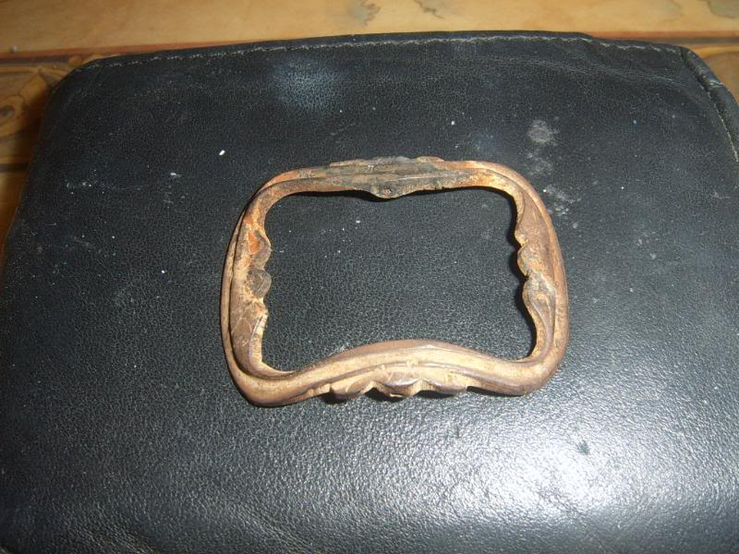
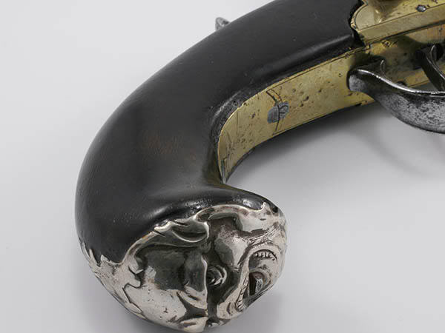
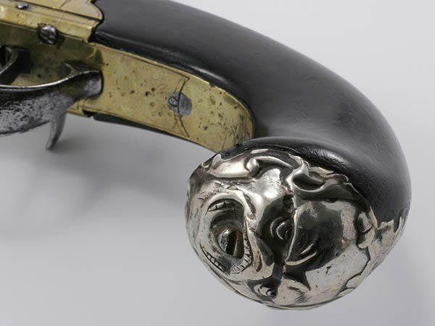
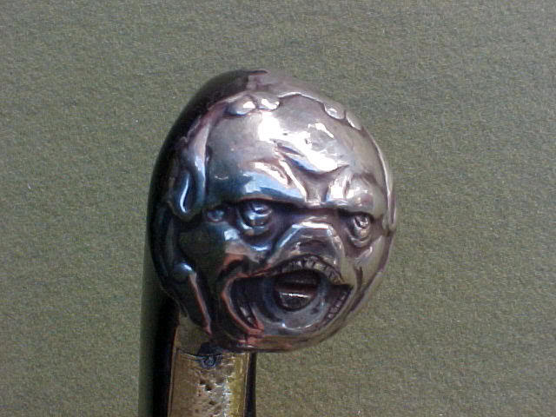
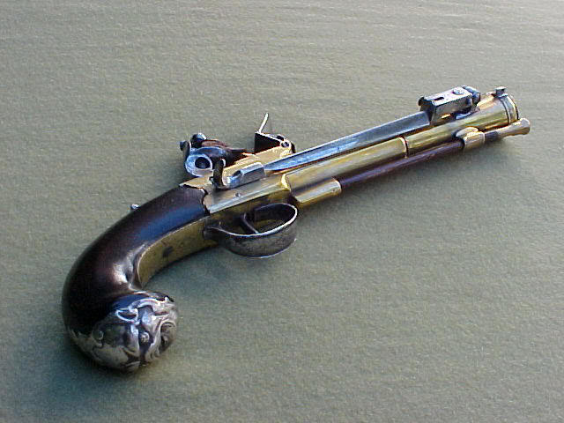

Cascabel
- Evil Drooling Henchman
- Moderator

- 848 posts
- Gender:Male
Posted November 8, 2009 · Report post
Along with pictures, size info would be helpful. Overall size, and width of the strap that the buckle fits, or at least estimated sizes on in-accessible examples in museum cases.
>>>> Cascabel

William Brand
- Mercury Malefactor
- Admin

- 8,884 posts
- Gender:Male
- Location:Logan, Utah
- Interests:My name is William Pace and I live and work as a graphic designer, illustrator and photographer in Northern Utah. I'm married to the lovely Tracy Pace and we have three children. In addition to all things art, I enjoy traveling and meeting new people from every walk of life. I've always been a fan of history, theology, and of course, Pyracy.
http://www.youtube.com/watch?v=PSkt-q-HihQ
Posted November 8, 2009 · Report post
Aye. Measure as often as possible. Approximate scales on museum pieces would be very helpful. I've often found that online auction houses will list the size of antiques for perspective buyers.

Gibbet Jones
- Deck Hand
- Member

- 91 posts
- Gender:Male
Posted November 8, 2009 (edited) · Report post
That is the Queen Ann pistol with a spring loaded bayonet is it not?
What kind of buckle is that? Can you get a shot of it directly from above?
Edited November 8, 2009 by Gibbet Jones

William Brand
- Mercury Malefactor
- Admin

- 8,884 posts
- Gender:Male
- Location:Logan, Utah
- Interests:My name is William Pace and I live and work as a graphic designer, illustrator and photographer in Northern Utah. I'm married to the lovely Tracy Pace and we have three children. In addition to all things art, I enjoy traveling and meeting new people from every walk of life. I've always been a fan of history, theology, and of course, Pyracy.
http://www.youtube.com/watch?v=PSkt-q-HihQ
Posted November 8, 2009 · Report post
This is listed as a late 17th century, early 18th century belt buckle. It is described as a copper alloy buckle with moulded decoration, a small fragment of leather survives attached to the central bar. No size is mentioned, but this is from a dig called the Chester Amphitheatre Project.

William Brand
- Mercury Malefactor
- Admin

- 8,884 posts
- Gender:Male
- Location:Logan, Utah
- Interests:My name is William Pace and I live and work as a graphic designer, illustrator and photographer in Northern Utah. I'm married to the lovely Tracy Pace and we have three children. In addition to all things art, I enjoy traveling and meeting new people from every walk of life. I've always been a fan of history, theology, and of course, Pyracy.
http://www.youtube.com/watch?v=PSkt-q-HihQ
Posted November 8, 2009 · Report post
This site is wonderful for documenting various cast objects of the period and later.
http://www.artifacts.org/

Commodore Swab
- Dread Pyrate
- Member

- 1,148 posts
- Gender:Male
- Location:Key Largo
- Interests:Flintlocks, Cannons, Ships, Sailing, antique cars
Posted November 8, 2009 · Report post
The picture of the buckle was taken while in the process of being cleaned. I can have better pictures with size once its cleaned, it is small for maybe a 3/4 inch belt (im guessing here).

Captain M the Frenchy
- Deck Hand
- Member

- 78 posts
- Gender:Male
- Interests:La piraterie!!!
Posted November 8, 2009 · Report post
Boucle France:

michaelsbagley
- Smells Like Wet Sheep
- 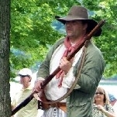
- Moderator

- 2,548 posts
- Gender:Male
- Location:Columbus, Ohio
- Interests:Mostly into GAoP, but starting to develop more Buccaneer era stuff for re-enacting as well. Generally I do re-enact both piratical/nautical and other impressions from the period. I am focusing on more "common" impressions from the period (i.e. average sailor/pirate, rank and file Red Coat, early Colonial huntsman, etc.)
Posted November 9, 2009 · Report post
Here is a small sampling of the extent buckles (and buttons) that I have in my collection.... There is a ton more, I just haven't taken photos yet.
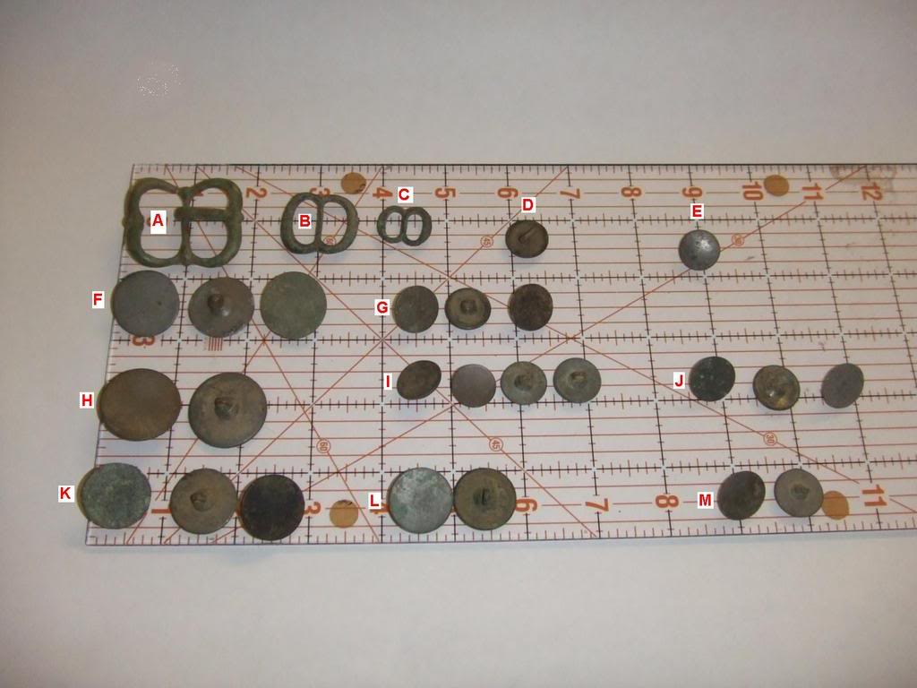

Gentleman of Fortune
- Dread Pyrate
- Member

- 1,456 posts
- Gender:Male
- Location:Germany... Franconia (northern Bavaria)
- Interests:I *used* to be an environmental scientist, until I married a DoDDs teacher in 1997. Since then, I have been living in, and traveling around, Europe (First the UK, now Germany).
My hobbies are all the "usual suspects" for those interested in re-enacting and Golden Age of Piracy stuff.... but I have drifted away from the pirate scene as my location and young family don't allow for any more than "virtual" pirate participation. Besides Piracy, I am into Reverend Guitars and Vintage Corvettes.
Posted December 7, 2009 · Report post
Dang....
Nice collection.

Captain McCool
- Pyrate Captain
- Member

- 530 posts
- Gender:Male
- Location:Golden, Colorado
- Interests:Piracy, of course. Also, skiing, fencing, graphite/charcoal drawing, writing, ren-faires, etc.
Posted December 20, 2009 · Report post
Oh dear... as if I needed fuel to add to my buckle fettish. Mate, if you start making shoe buckles, I'd totally be down for getting a pair of fancy ones, if I could fit them to the Loyalist Arms early 18th century shoes, which I have been meaning to get for a while.

PoD
- Pyrate Captain
- Member

- 697 posts
- Gender:Male
- Location:Warrington UK
- Interests:Pirates, graphic novels, computer art, Listening to music, Going to gigs, Beer and Wine drinking, historical research, Period weaponry and Leatherwork
Posted December 26, 2009 (edited) · Report post
Elaborate 17th-18th century bronze buckle. 50mm from ebay
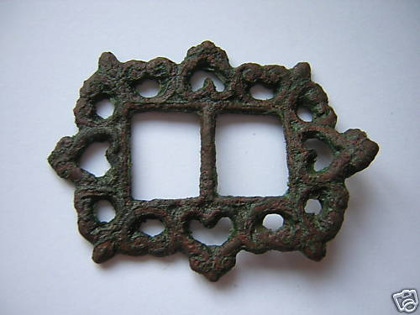
Edited December 26, 2009 by PoD

Captain McCool
- Pyrate Captain
- Member

- 530 posts
- Gender:Male
- Location:Golden, Colorado
- Interests:Piracy, of course. Also, skiing, fencing, graphite/charcoal drawing, writing, ren-faires, etc.
Posted December 27, 2009 · Report post
At the risk of being scorned for referencing "the Dreadlocked One" in a thread about historical buckles, is it just me, or does that one almost, sort-of, vaguely resemble Jack Sparrow's baldric buckle from movies 2 and 3?

PoD
- Pyrate Captain
- Member

- 697 posts
- Gender:Male
- Location:Warrington UK
- Interests:Pirates, graphic novels, computer art, Listening to music, Going to gigs, Beer and Wine drinking, historical research, Period weaponry and Leatherwork
Posted December 27, 2009 · Report post
On 12/27/2009 at 0:50 AM, Captain McCool said:
At the risk of being scorned for referencing "the Dreadlocked One" in a thread about historical buckles, is it just me, or does that one almost, sort-of, vaguely resemble Jack Sparrow's baldric buckle from movies 2 and 3?
It's not to far off but the one pictured above is a lot smaller I would say

CaptSkinner
- Deck Hand
- Member

- 63 posts
- Gender:Male
- Location:Concord, NC
- Interests:Pirates, Old West, SciFi, leatherwork, making costumes and fishing.
Posted March 6, 2010 · Report post
Found a great reference. Buckles 1250-1800

Captain McCool
- Pyrate Captain
- Member

- 530 posts
- Gender:Male
- Location:Golden, Colorado
- Interests:Piracy, of course. Also, skiing, fencing, graphite/charcoal drawing, writing, ren-faires, etc.
Posted March 6, 2010 · Report post
Awesome!

Jas. Hook
- Scourge o' the 7 Seas
- Member

- 1,650 posts
- Gender:Male
- Location:Long Island NY
- Interests:Fishing & Piracy
Posted March 6, 2010 · Report post
Ditto! Great find Capt. S
Jas. Hook

LadyBarbossa
- Wealth Redistributor & Mischief Making
- Moderator

- 4,641 posts
- Gender:Female
- Location:The Land Between Two Rivers, aka Iowa
- Interests:18th c Piracy to American Revolution, Victorian Thespians, Equitation, tigers, Friesians, cooking, playing my viola & music in general. Researcher of Major General Baron Johann de Kalb. LOVES the Phantom of the Opera (who's also Brethren)! Transformers, Stargate, Star Trek, Star Wars, NCIS, Bones, The X Files
Posted March 6, 2010 · Report post
Ye gents are EEEEEVVVIIIIIIIILLLLL!!!!
Especially for a Lady such as m'self who's ALWAYS lookin' for fine things t' adore m' attire. Th' buckles are right nice.
~Lady B

PoD
- Pyrate Captain
- Member

- 697 posts
- Gender:Male
- Location:Warrington UK
- Interests:Pirates, graphic novels, computer art, Listening to music, Going to gigs, Beer and Wine drinking, historical research, Period weaponry and Leatherwork
Posted March 20, 2010 · Report post
I just bought a couple of buckles and bits off ebay with the hopes of reproducing them somehow or at least using them as the basis for some larger buckles.

Elaborate 17th-18th Century Bronze Buckle

Queen Anne Period Bronze Buckle 1710

17th-18th century cupid type bronze belt hanger

Attractive 17th century bronze open-work fitment

